Q1. **Remote Desktop Sharing within LAN using SSH in Cisco Packet Tracer**1. Setup Network Topology

1. Add the following devices: o 1 Server (SSH Server) o 1 or more PCs (SSH Clients) o 1 Switch
2. Use Copper Straight-Through cables to connect the PCs and Server to the Switch. 2. Assign IP Addresses

* On the SSH Server:
* On the SSH Client (PC1):

3. Configure the Server for SSH

1. Click on Server → Go to Services → Click on SSH.
2. Ensure the SSH service is turned ON.
3. Set the following:

o Username o Password o Enable SSH

4. Access SSH from the Client PC

1. Click on the Client PC → Go to Desktop → Open Terminal.
2. Run the following command: 3. ssh -l admin 192.168.1.1 o -l admin → Specifies the username (e.g. admin). o 192.168.1.1 → IP of the SSH Server.
3. When prompted, enter the password
4. If successful, you should get a remote command-line interface (CLI) of the server. 5. Verify SSH Connection

* Run a command like:
* show ip interface brief
* If the SSH session is working, it will display the server’s interface details.

## Topology

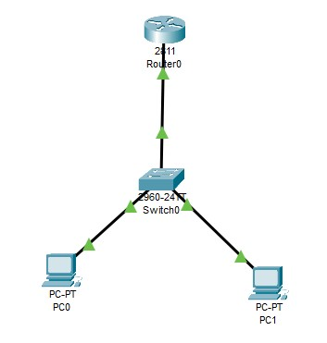

## PC0 Configuration

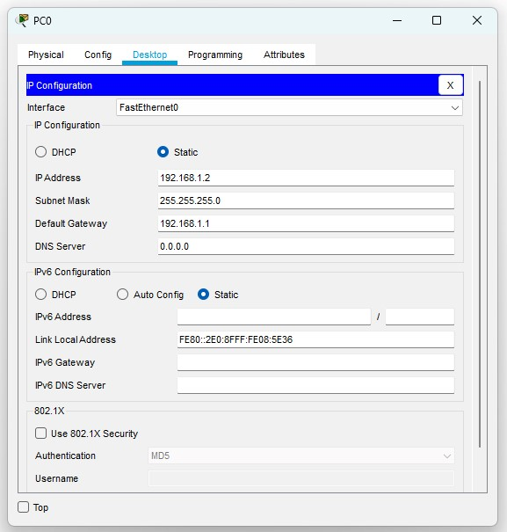

## PC1 Configuration

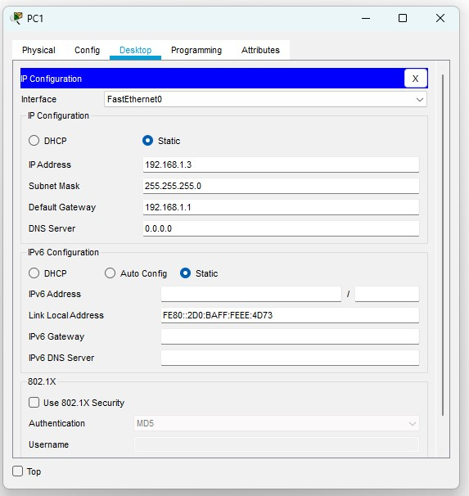

## Router Configuration

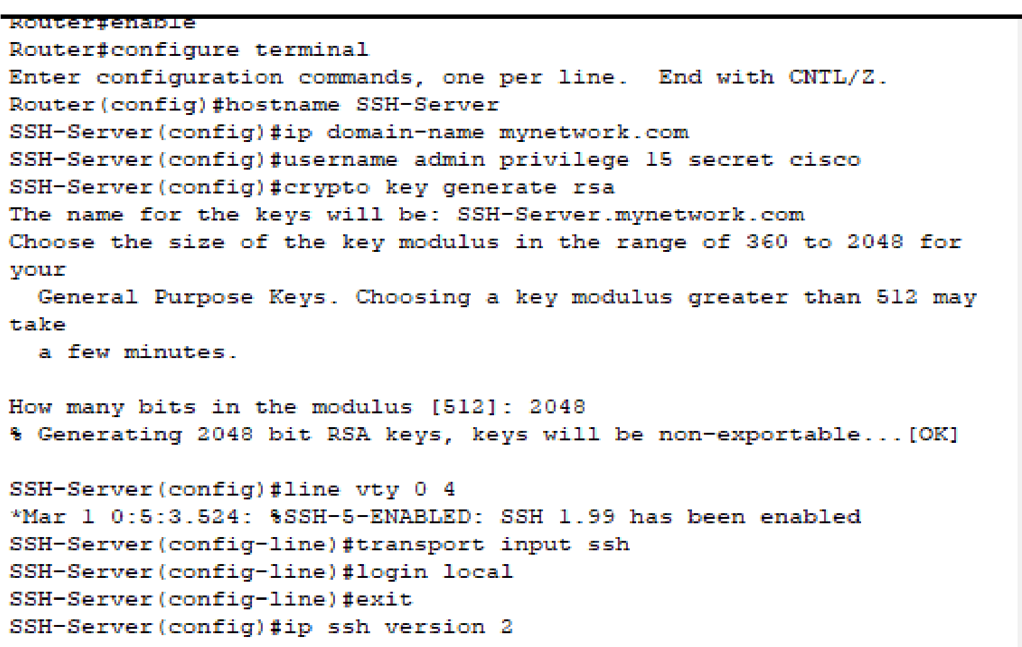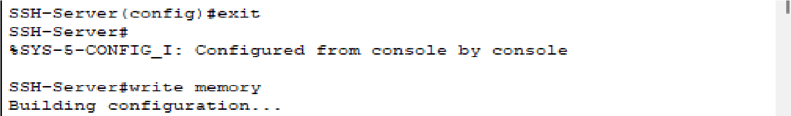

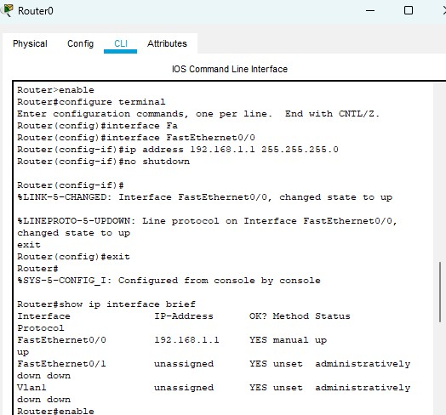

## Final Result

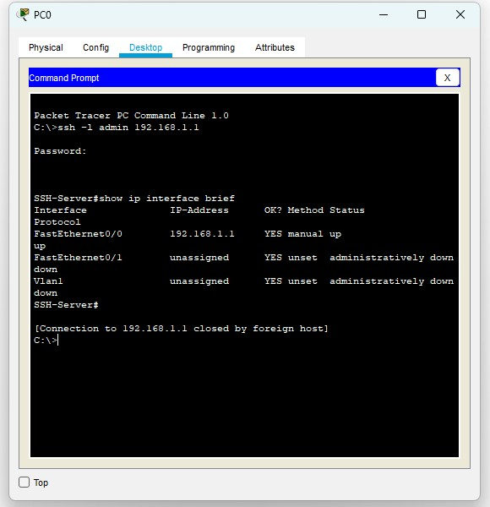

**Q2. Implement a Client-Server Network in Cisco Packet Tracer** 1. Setup the Network Topology

1. Add Devices:

one Server from the End Devices section.

one or more PCs as clients.

one switch from the Network Devices section.

1. Connect the Devices:

Use Copper Straight-Through cables to connect the PCs and Server to the Switch.

1. Configure IP Addresses

Assign static IPs to the server and clients:

Set IP Address

Set Subnet Mask

Set Default Gateway for clients: 192.168.1.1 (Server's IP)

1. Configure the Server

Click on the Server → Go to Services tab:

Enable DHCP (if dynamic IP assignment is needed).

Enable HTTP/HTTPS for web access.

1. Test the Network

* Open the Command Prompt on each PC and ping the server:
* ping 192.168.1.1

If the response is successful, the network is working.

* Open a web browser on the client PC and enter [http://192.168.1.1](http://192.168.1.1/) to check if the web service is running.

### Topology

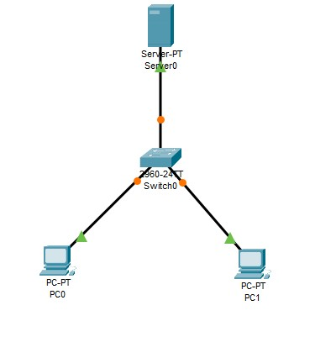

### PC 0

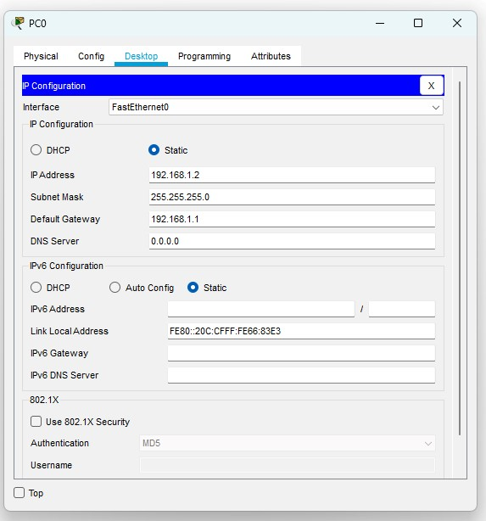

### Server

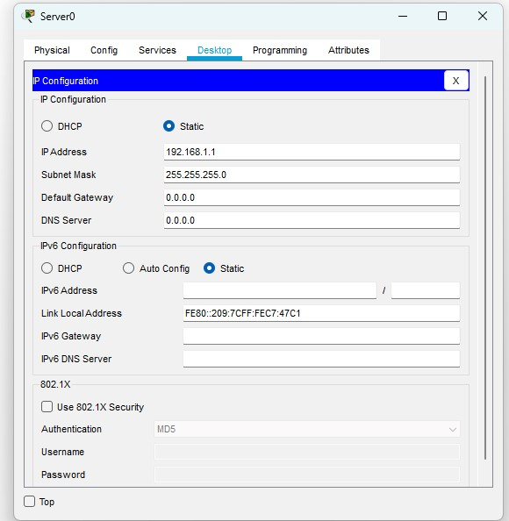

### Final Result

PC0

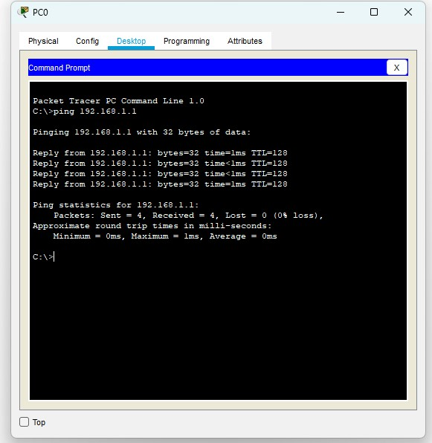

Pc1

